Project 1:

Deploying a web server in windows instance

1. creating a windows instance

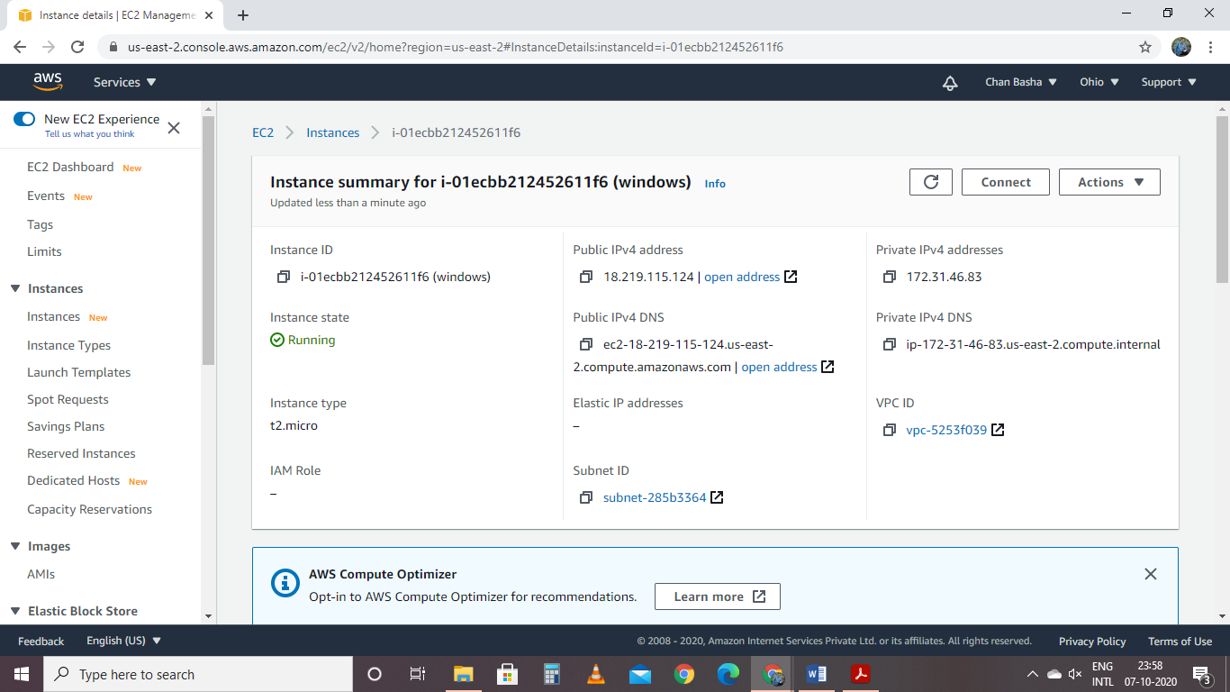

Launching RDP

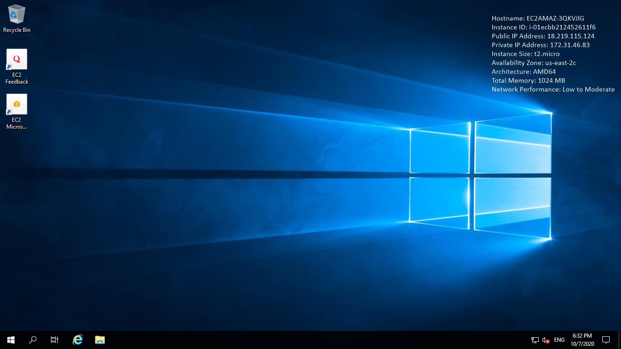

Accessing Webserver by using public IP

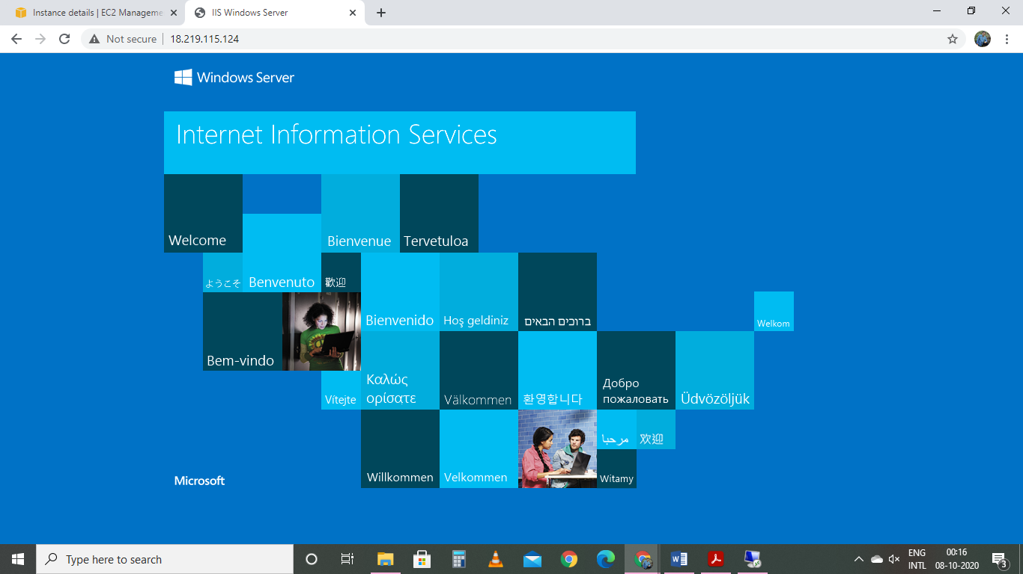

Project 2:

Installing Nginx web server in Ubuntu

Creating Ubuntu server

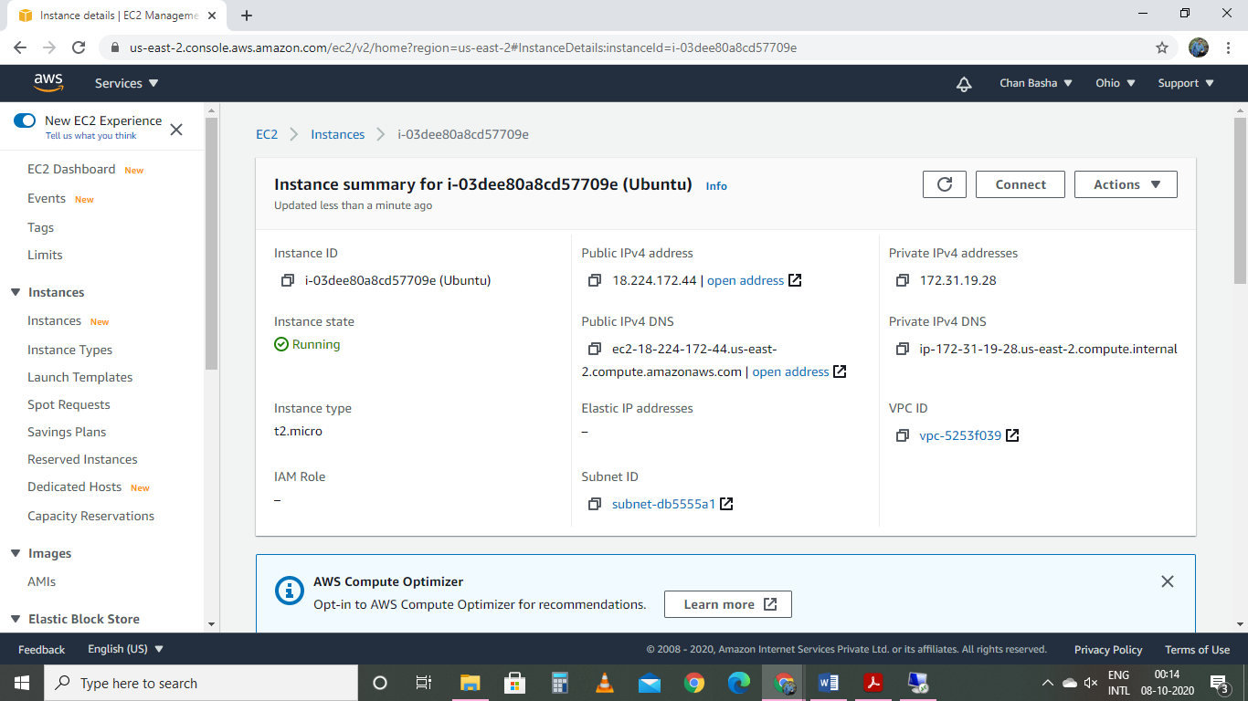

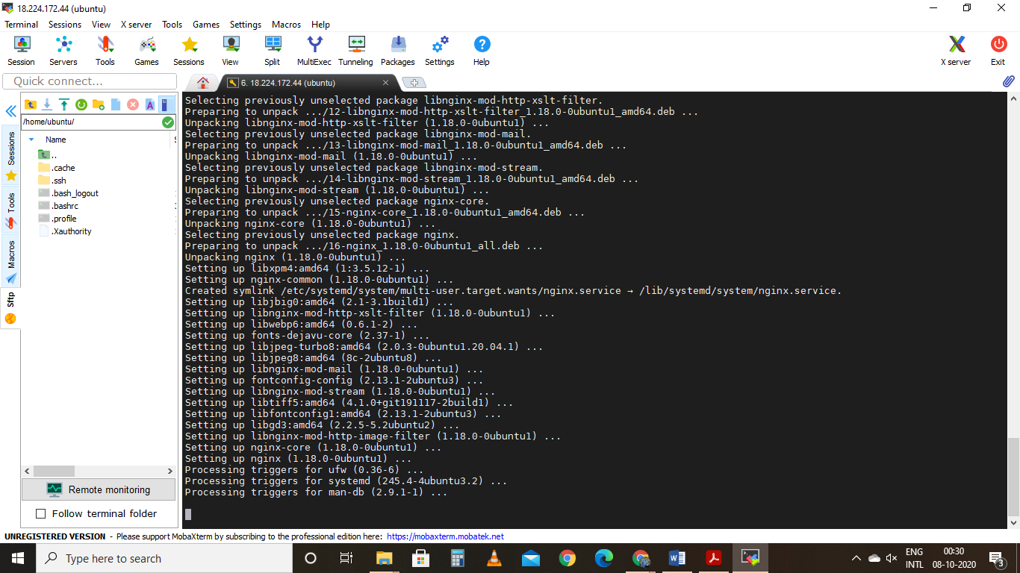

Accessing Nginx by using Public IP

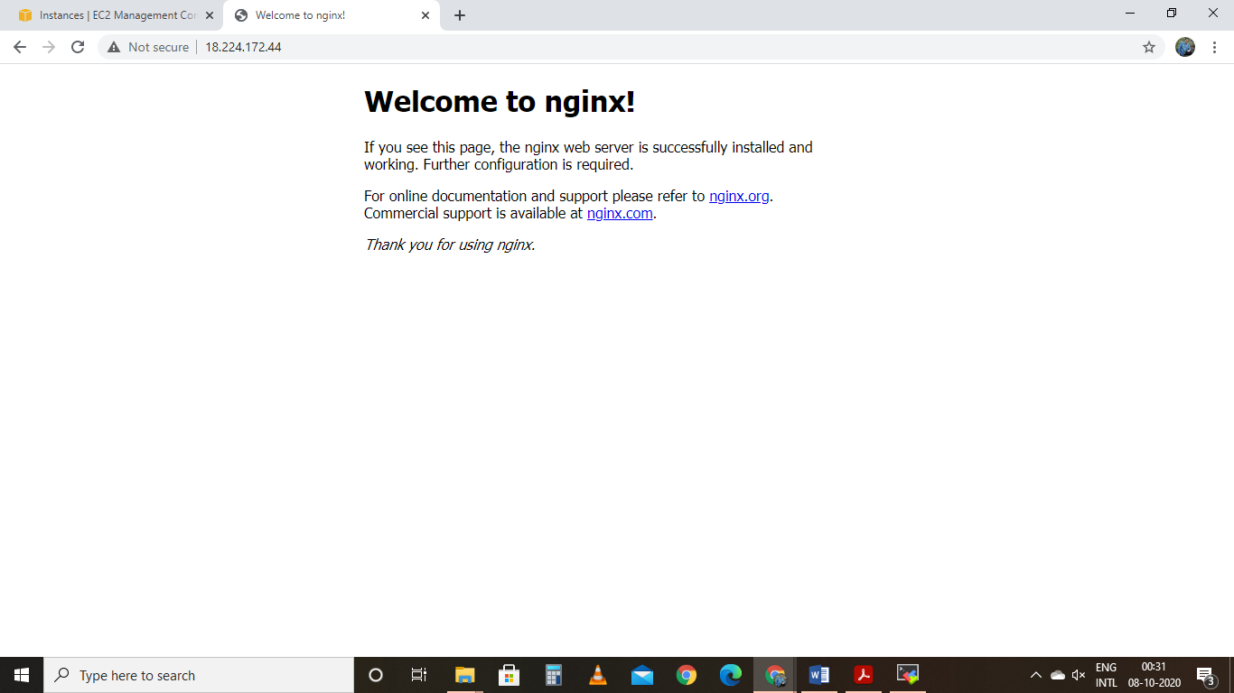

Project 3:

Working with Volumes

Creating EBS volume

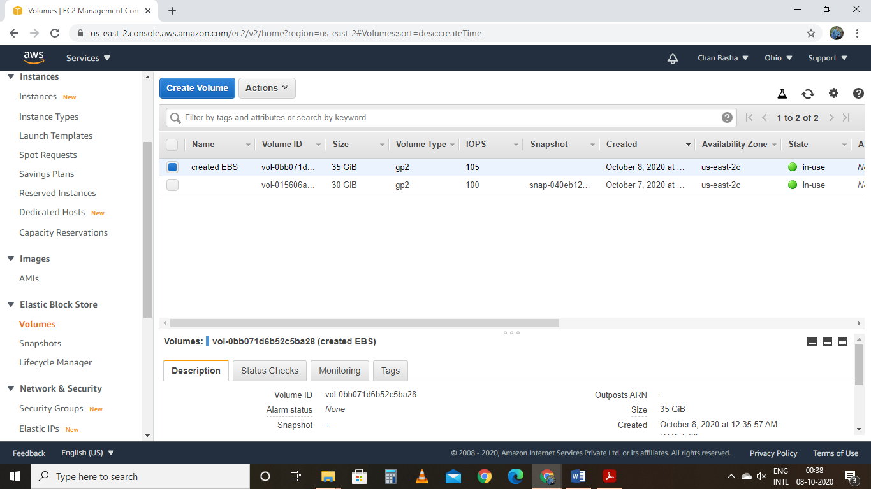

Bringing newly created EBS volume into online

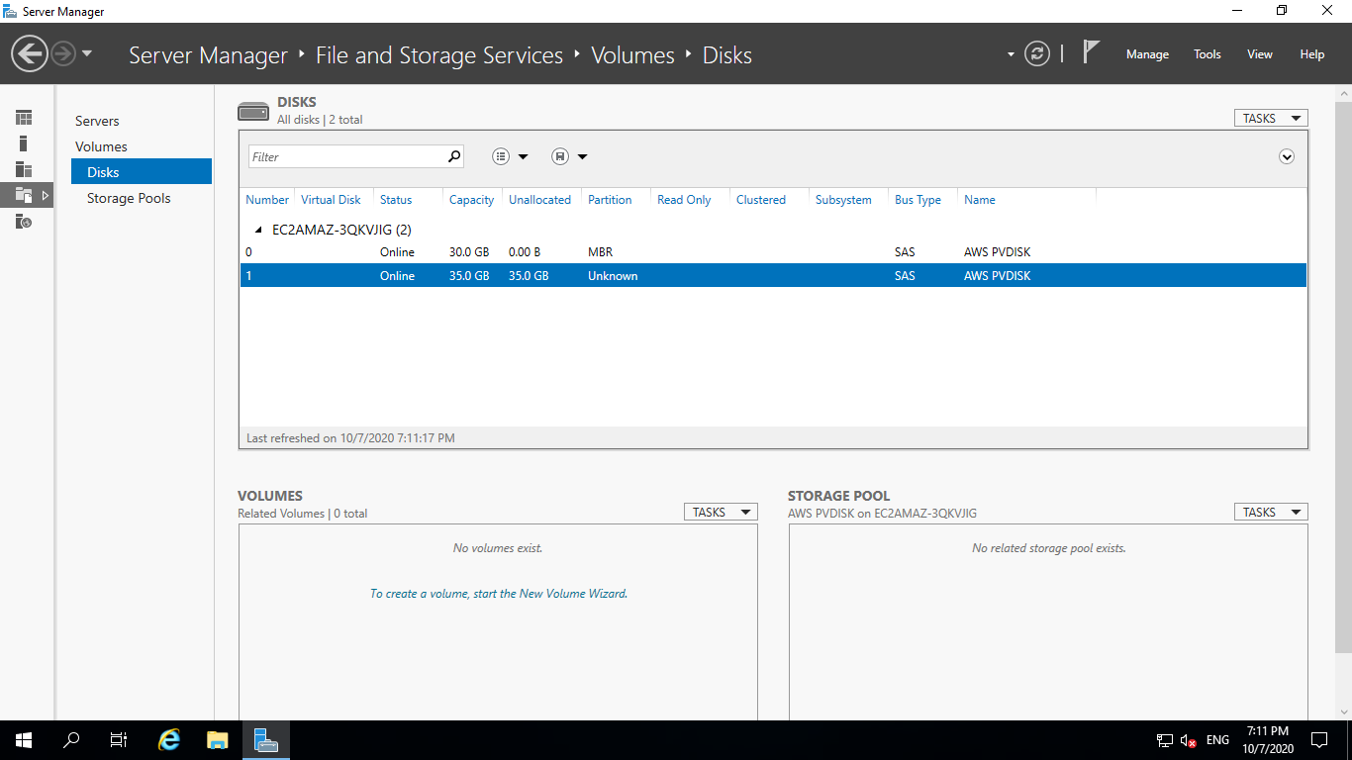

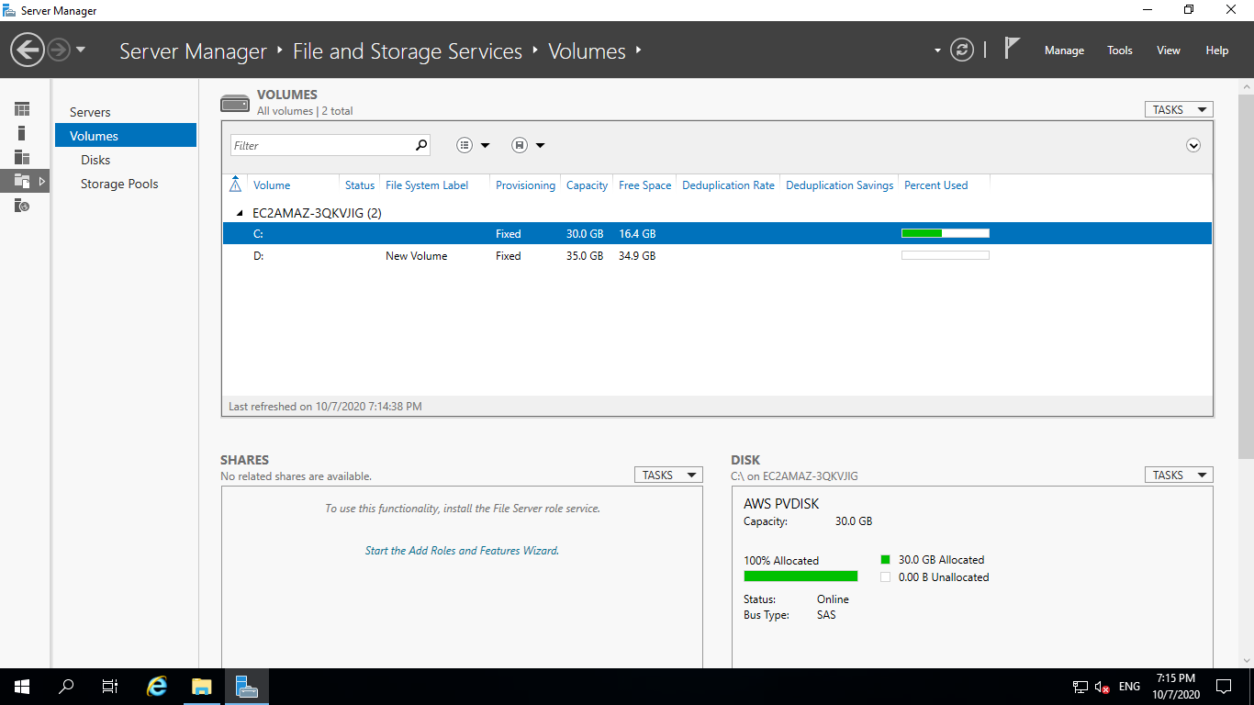

Newly mounted Volume

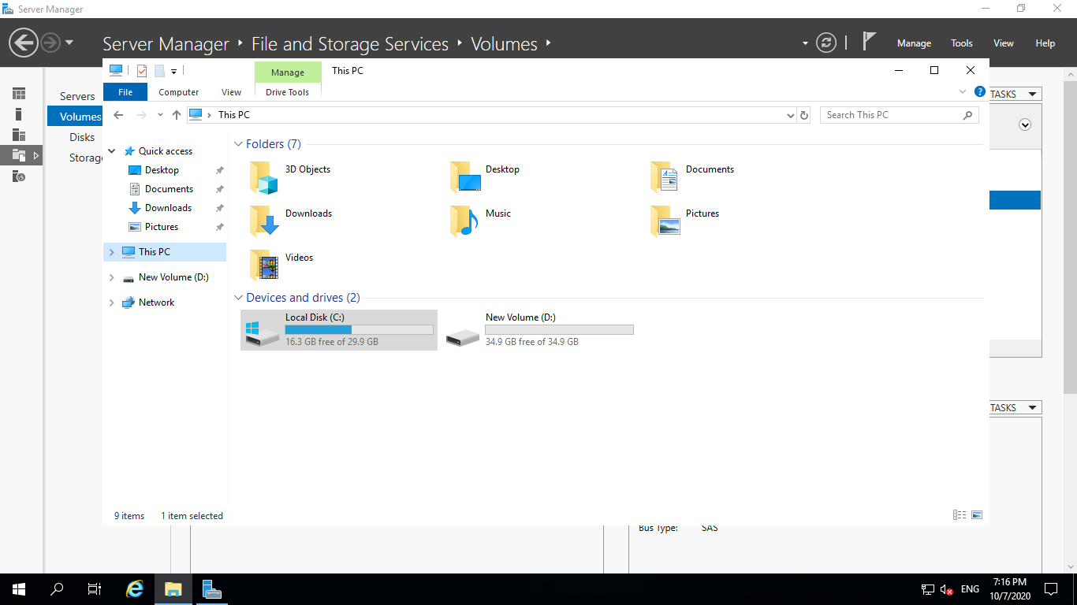

Modified EBS

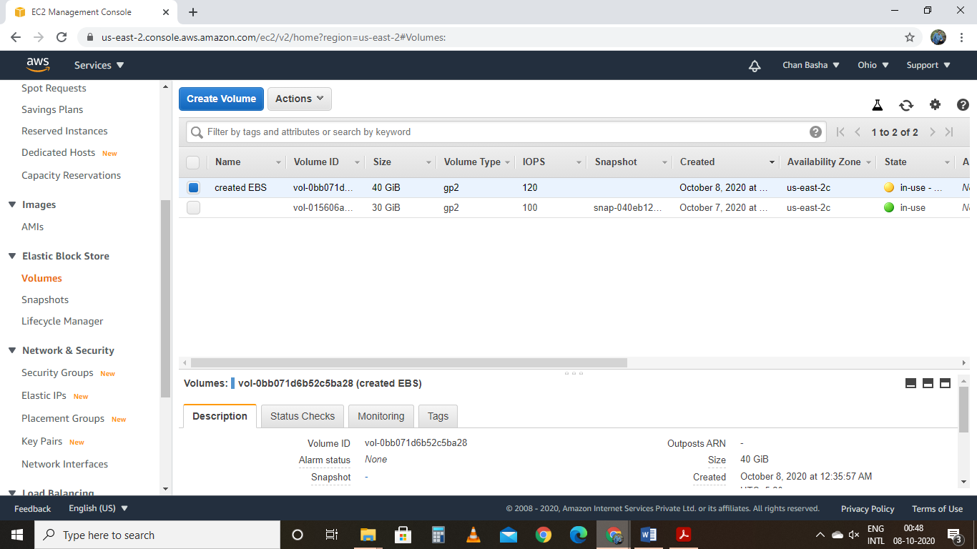

Project 4:

Installing Apache server

Creating linux instance

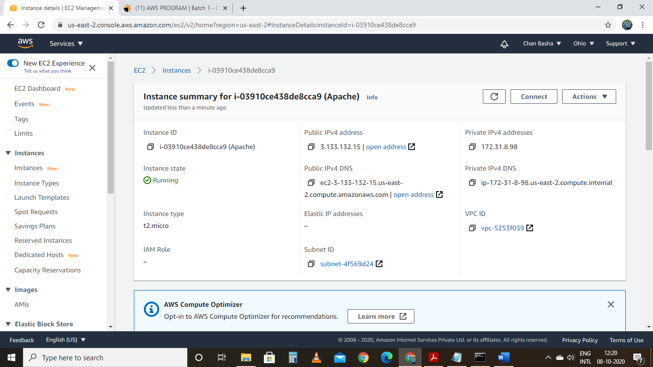

Accessing Apache by using Public IP

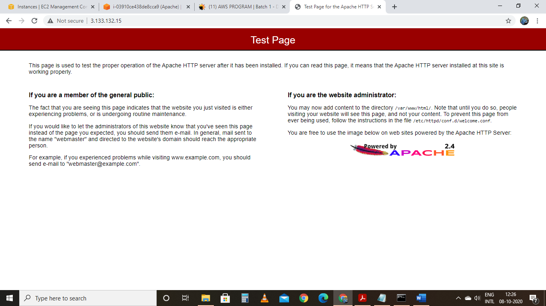

Working with Elastic IP

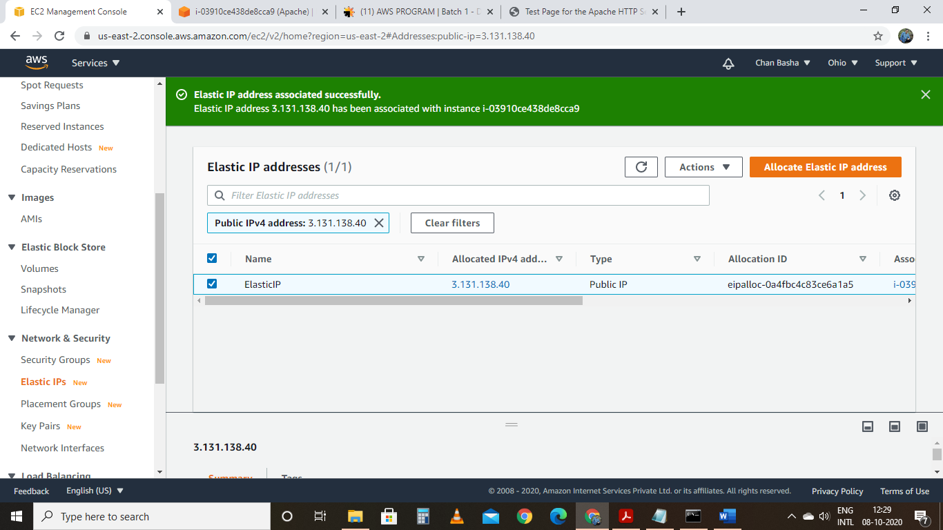

Attaching the Elastic IP to instance

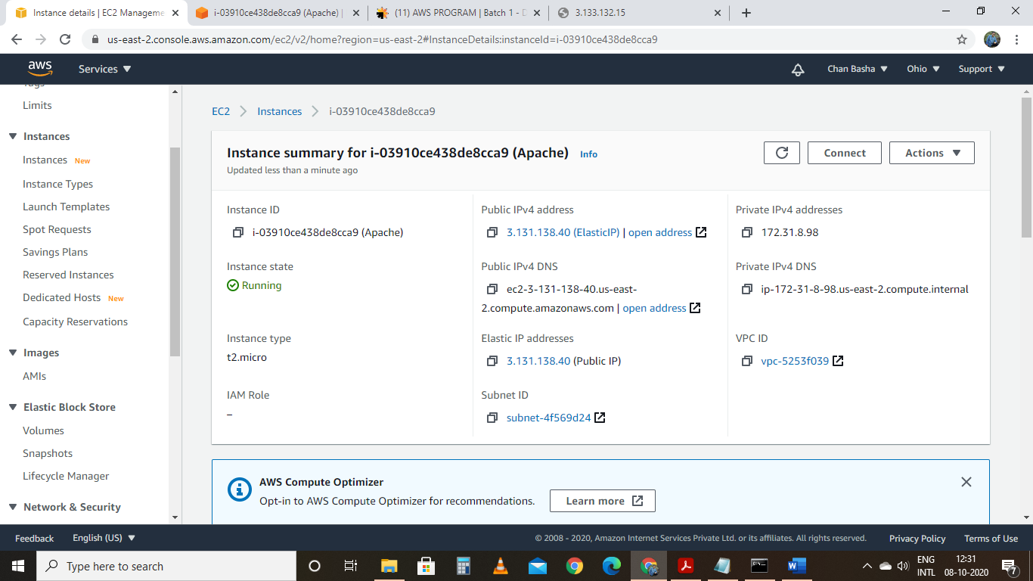

Accessing Apache by Elastic IP IP which is attached to instance

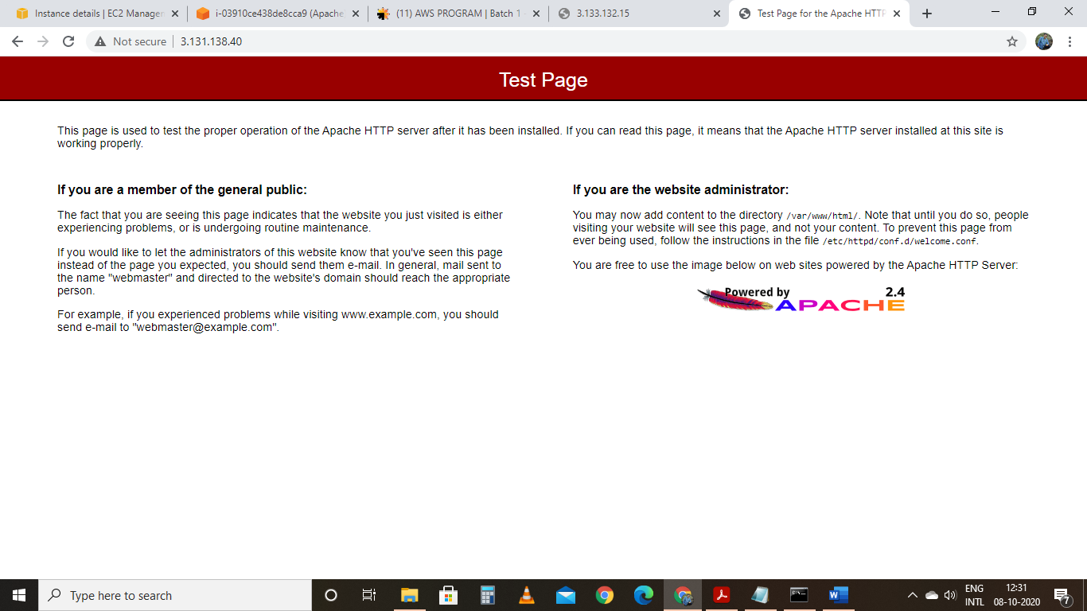

-🡪 when Elastic IP gets attached to instance public IP gets changed we cannot able to access the applications installed with in instance by using old Public IP

Project 5:

Creating a S3 object

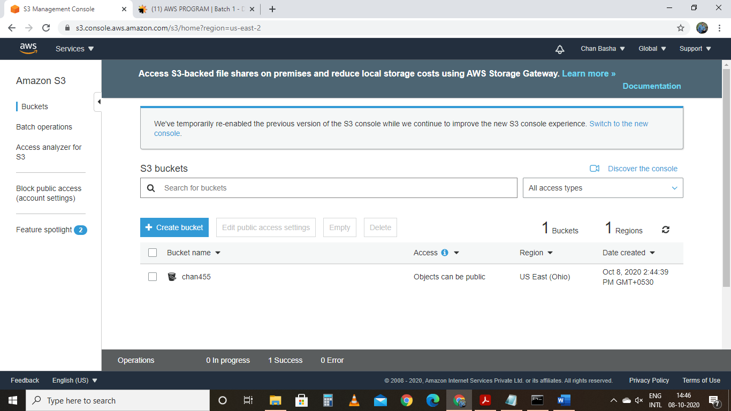

Accessing folders in bucket

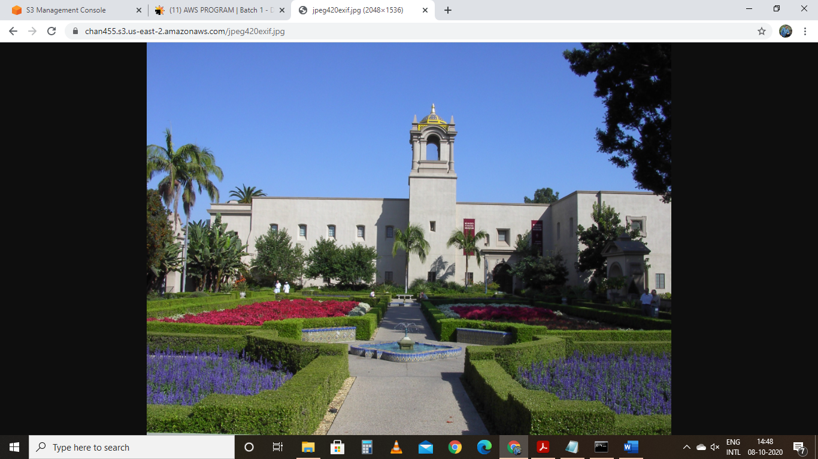

Creating a Static Website hosting

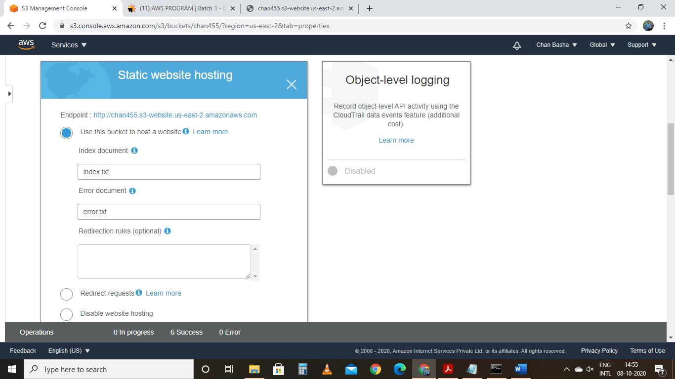

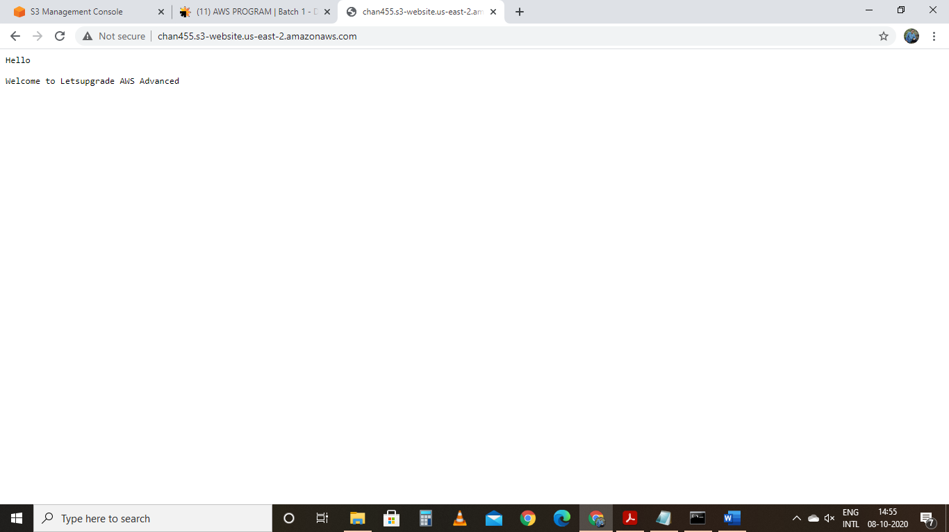

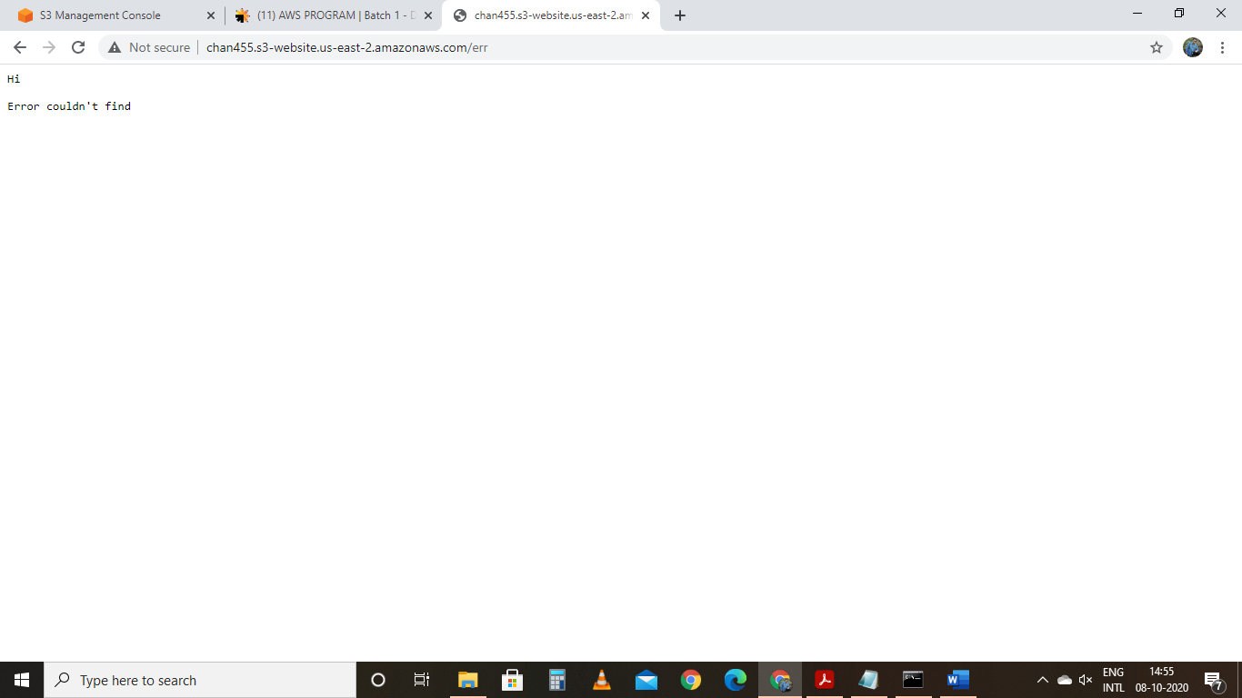

Working with Object Versioining

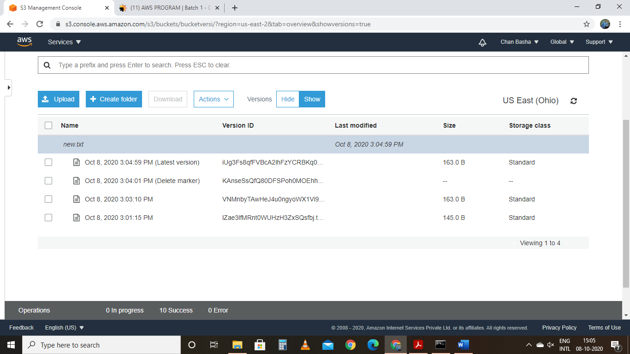

1. Life cycle effects on instance

* Stop: by making the instance stop means making instance shutdown cant able to access instance until beomes available
* Start: we can make instance active up and running after when instance made to stop
* Public -IP: It is used for the instances to able to access the Internet
* Private – IP: it is used to communicate with the instances with in local network
* Terminating instance : we are no longer able to access the instance
* Static IP: IP address remains same same even after restarting instance
* When we stop and start the instance Public IP which is associated with the instance gets changed but private IP remains same. We are no longer able to access the applications installed in the system with old public IP.